Steps to add VBA macro

1. Import the modPERTFunctionality.bas file in the **ProjectGlobal(Global.MPT)** project.  
   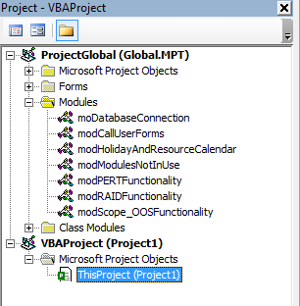
2. To easily access the functions of this macro, I’ve added an icon on the Quick Access Toolbar of MS Project.  
     
    - Show PERT fields  
   - Hide PERT fields  
   - Calculate Estimated Activity Duration (E)  
    - Get Duration as per Sigma values
3. Below is how to add these macros to the top bar;  
   Click on the down arrow visible on the top bar, and then click on More Commands.  
     
     
   You should see the Project Options dialog. Here select “Quick Access Toolbar” in the left section and then choose “Macros” from the “Choose commands from” drop down. The list of Public macros will be shown. I’ve added the 4 Macros which I’ve shown in point # 2 above. Once done click on OK and you should be able to see the icons in the Quick Access Toolbar.  
   